Nikita Persikov
ASTE 404
HW3 (Code Outputs and Plots)
9/12/2021
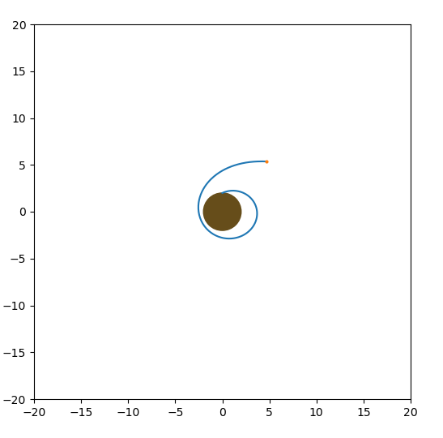
Parts 1-3 (Simple Orbit Plot):

Part 4: Animation Screenshots:

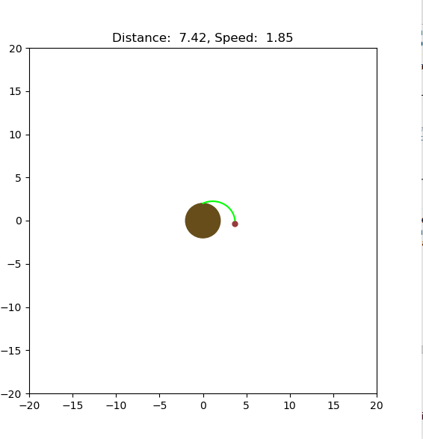
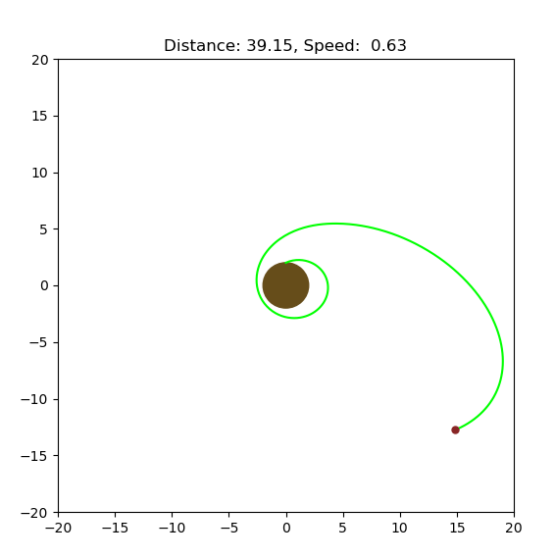
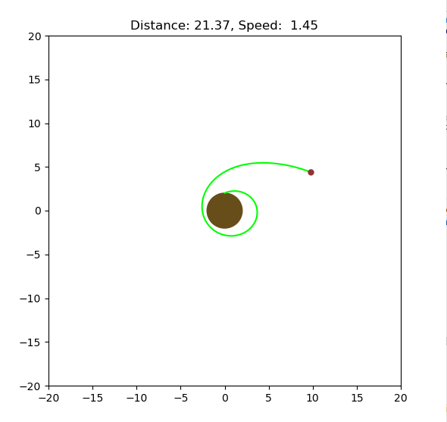

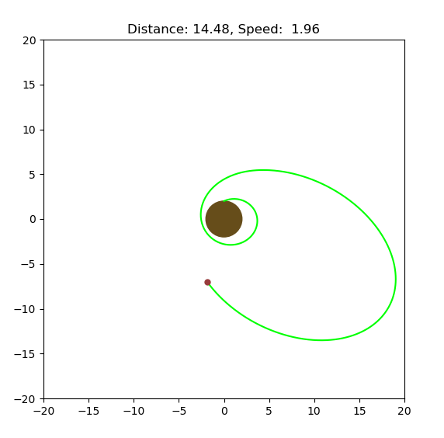
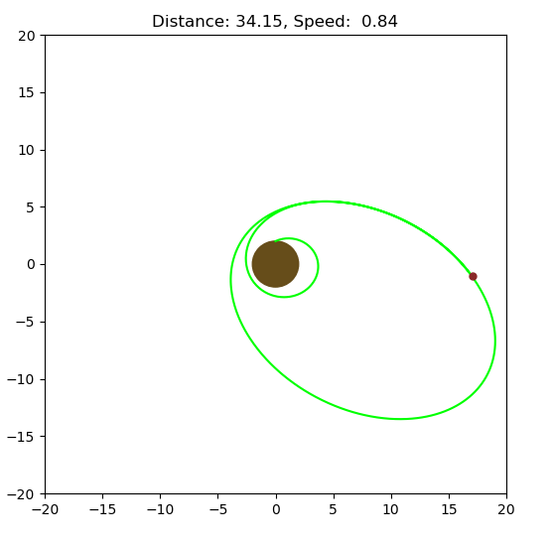

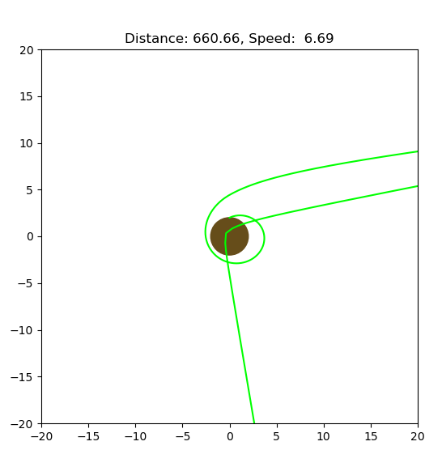
Part 5: Animation with Live Input

This first image shows the use of an impulsive monopropellant burn at the point above the launch site. After some distance, a few reverse burns are used to bring the spacecraft back. It then impacts the planet (or if it was a point mass it would shoot off to the negative y axis as shown.

The rest of the images are a sequence that tested the ion thruster and used two (or three?) backward mono thruster burns to change orbit.



